Test Case: tc006_SPX_Dev5_Crear_Requisicion_Spot_Tipo_Cobro_Proyect_Urgent
Step 1 - Enter username and password and click to button Enter: Credentials Entered
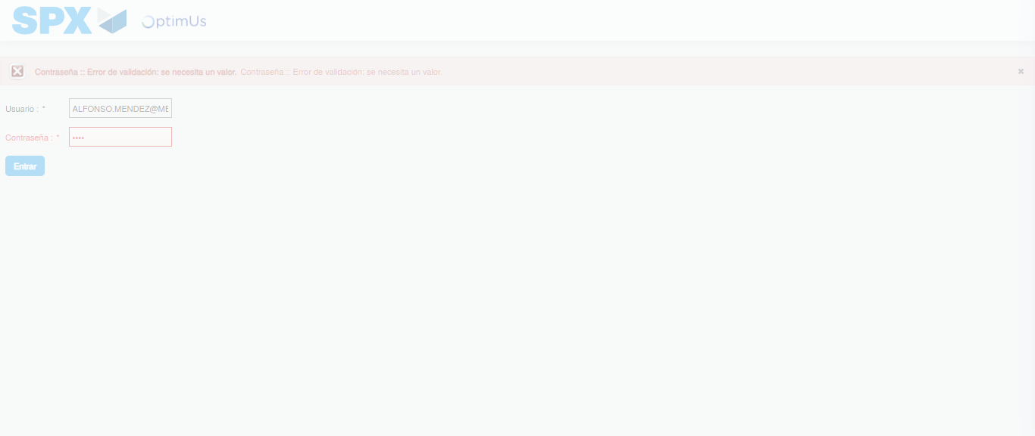Image file-name: QC_Testing-tc006_SPX_Dev5_Crear_Requisicion_Spot_Tipo_Cobro_Proyect_Urgent-1783379647368

Step 2 - Select to UEN and Access to Spot Buy Requisitions : UEN Correctly selected and Correct access
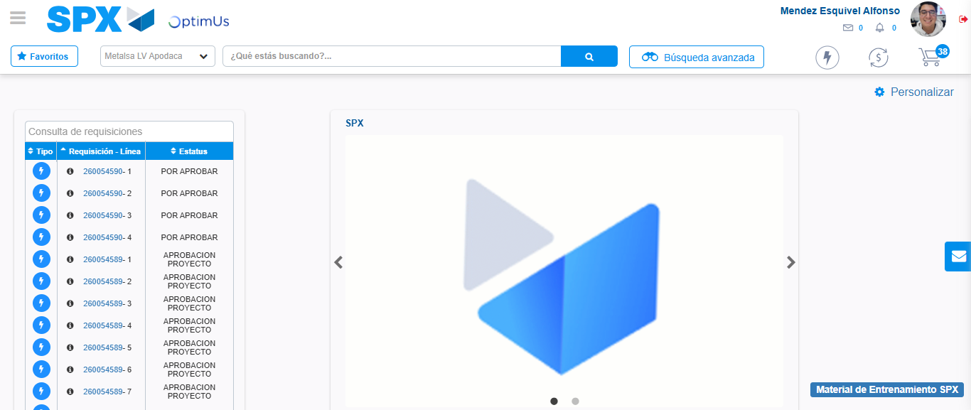Image file-name: QC_Testing-tc006_SPX_Dev5_Crear_Requisicion_Spot_Tipo_Cobro_Proyect_Urgent-1783379673066

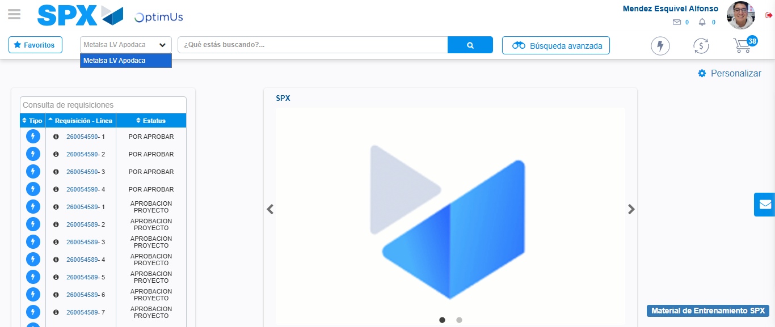Image file-name: QC_Testing-tc006_SPX_Dev5_Crear_Requisicion_Spot_Tipo_Cobro_Proyect_Urgent-1783379675528

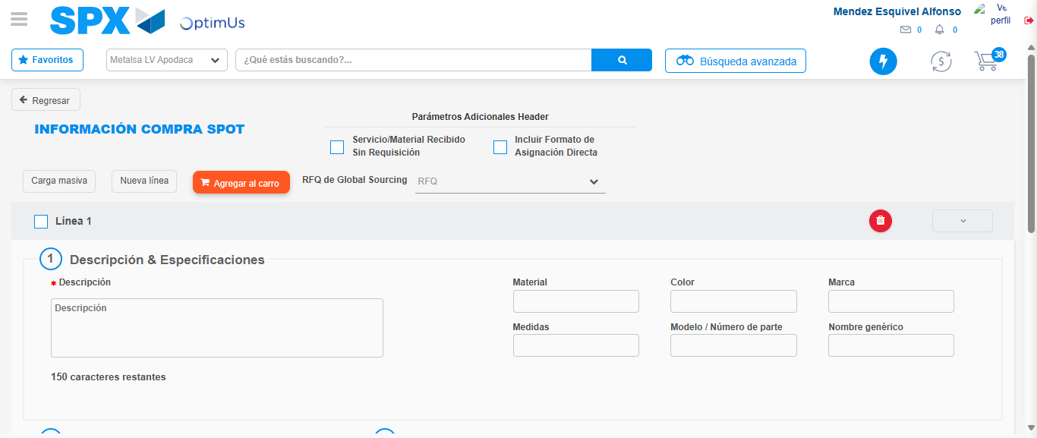Image file-name: QC_Testing-tc006_SPX_Dev5_Crear_Requisicion_Spot_Tipo_Cobro_Proyect_Urgent-1783379693674

Step 3 - Data Capture Spot Buy Requisition: Data captured correctly
Image file-name: QC_Testing-tc006_SPX_Dev5_Crear_Requisicion_Spot_Tipo_Cobro_Proyect_Urgent-1783379693929

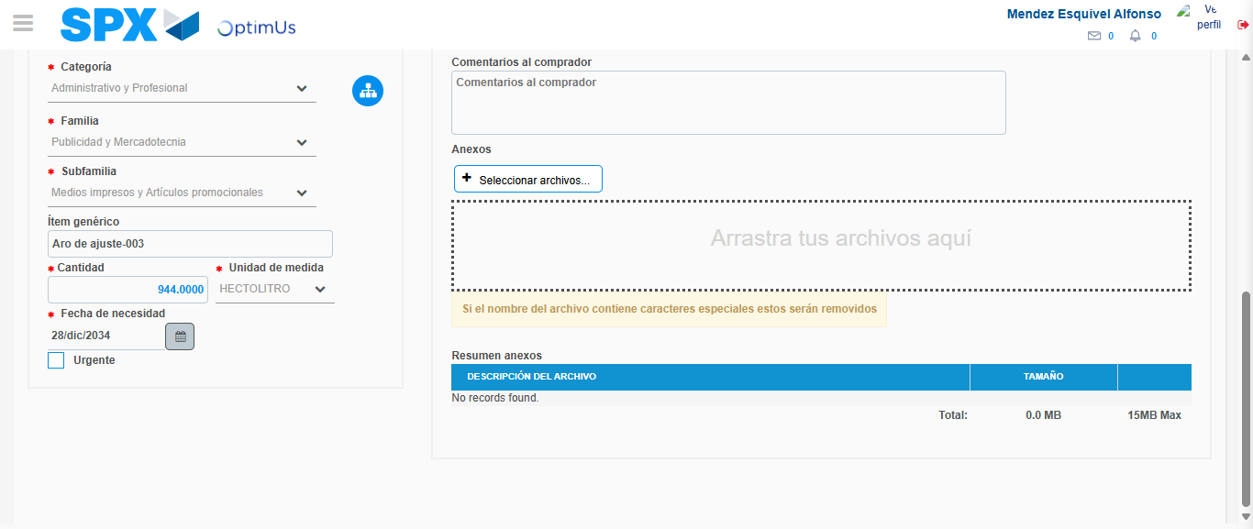Image file-name: QC_Testing-tc006_SPX_Dev5_Crear_Requisicion_Spot_Tipo_Cobro_Proyect_Urgent-1783379703693

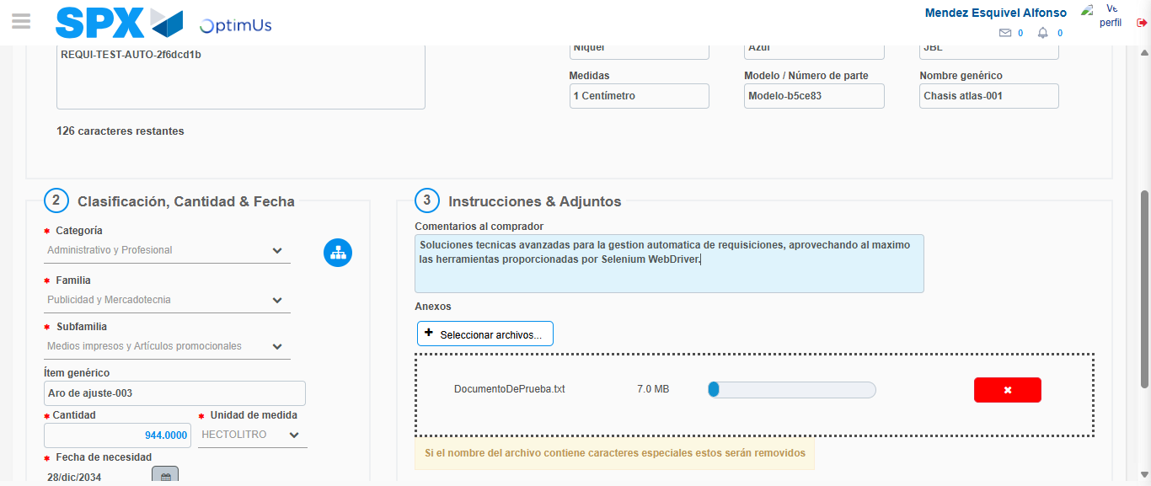Image file-name: QC_Testing-tc006_SPX_Dev5_Crear_Requisicion_Spot_Tipo_Cobro_Proyect_Urgent-1783379704397

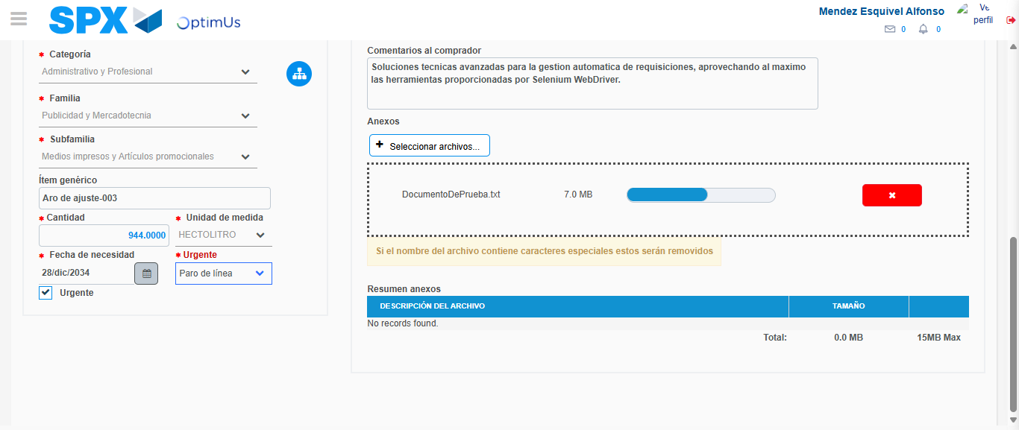Image file-name: QC_Testing-tc006_SPX_Dev5_Crear_Requisicion_Spot_Tipo_Cobro_Proyect_Urgent-1783379707592

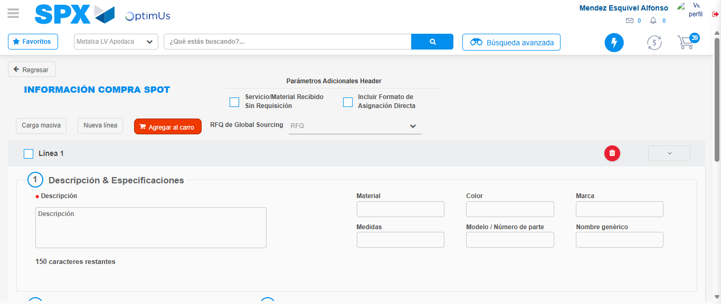Image file-name: QC_Testing-tc006_SPX_Dev5_Crear_Requisicion_Spot_Tipo_Cobro_Proyect_Urgent-1783379715488

Step 7 - Return to Main Page SPX : Return to Main Page SPX
Image file-name: QC_Testing-tc006_SPX_Dev5_Crear_Requisicion_Spot_Tipo_Cobro_Proyect_Urgent-1783379673066

Image file-name: QC_Testing-tc006_SPX_Dev5_Crear_Requisicion_Spot_Tipo_Cobro_Proyect_Urgent-1783379675528

Image file-name: QC_Testing-tc006_SPX_Dev5_Crear_Requisicion_Spot_Tipo_Cobro_Proyect_Urgent-1783379693674

Image file-name: QC_Testing-tc006_SPX_Dev5_Crear_Requisicion_Spot_Tipo_Cobro_Proyect_Urgent-1783379717738

Image file-name: QC_Testing-tc006_SPX_Dev5_Crear_Requisicion_Spot_Tipo_Cobro_Proyect_Urgent-1783379717925

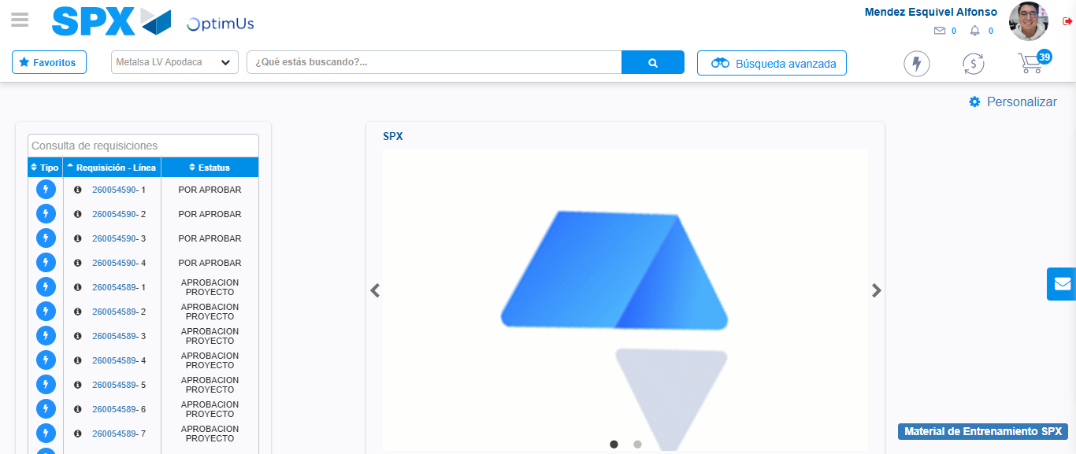Image file-name: QC_Testing-tc006_SPX_Dev5_Crear_Requisicion_Spot_Tipo_Cobro_Proyect_Urgent-1783379739051

Step 8 - Log Out : Log Out SPX
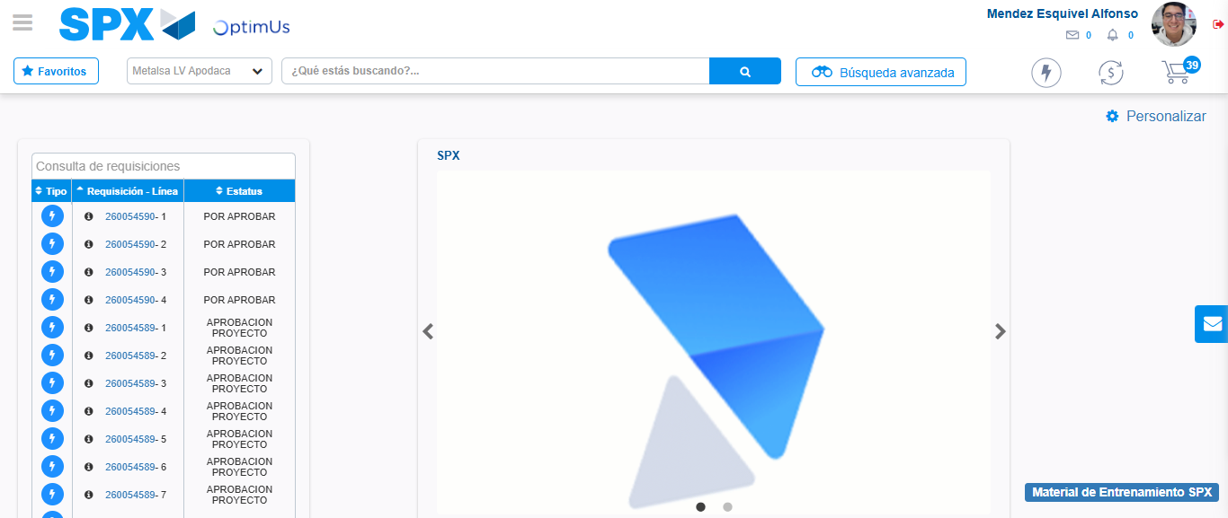Image file-name: QC_Testing-tc006_SPX_Dev5_Crear_Requisicion_Spot_Tipo_Cobro_Proyect_Urgent-1783379739286

